II B.Tech II Semester Regular/Supplementary Examinations – May, 2025
THEORY OF COMPUTATION
(CSE)
Time: 150 Min Max. Marks:60M
SECTION – A
Answer all Four questions 4×08M=32M

1.
(a) | Differentiate between NFA and DFA. | [2M]
(b) | Let $Σ$ = {a, b}, Design a DFA that accepts any string with ‘aababb’ as a  substring. | [2M]
(c) | Construct the minimal DFA for the below DFA  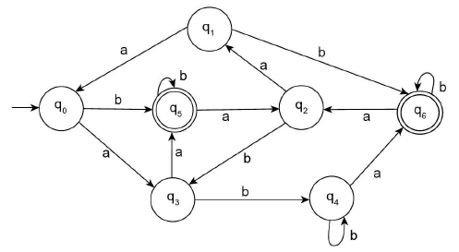 | [4M]
2.
(a) | What is regular expression? Write the regular expression for the following languages over {0, 1} *  - The set of all strings that contain exactly three 1’s | [2M]
(b) | Design a FA equivalent to the regular expression (0* 11* + 101). | [3M]
(c) | Prove that the language L = {a^{2n} b^{3n} a^{n} | n ≥ 0} is not regular. | [3M]
3.
(a) | What is a Context Free Grammar? List the closure properties of CFG | [2M]
(b) | Consider the CFG with the following production rules:  S → aB / bA  A → bAA / aS / a  B → aBB / bS / b  Give the right most derivation and draw derivation tree for the string “abbaab” | [3M]
(c) | Design a PDA that accepts language L = {ww^{R} | w $ϵ {(a+b)}^{*}$} | [3M]
4.
(a) | What is PDA? Give an example. In what ways a PDA can show the acceptance  of a string. Explain with example. | [3M]
(b) | List and explain the types of Turing machines? | [2M]
(c) | Design a Turing machine to accept all set of even length palindromes over  {0, 1} *, and also construct the transition diagram and Instantaneous description on the string ‘101101’. | [3M]

SECTION - B
Answer all Two questions 2×14M=28M

5.
(a) | Prove that L = a^{n}b^{n}c^{2n} is not context free by using the pumping lemma for CFL. | [4M]
(b) | Consider the CFG with {S, X, Y} as the non-terminal alphabet, {m, n, o} as the terminal alphabet, S as the start symbol and the following set of production rules:  S → XY | Xn | p  X → mX | m  Y → Xn | o  Convert the given CFG into Greibach Normal Form (GNF). | [5M]
(c) | Design a Turing Machine would that accept a string from the language  L = $WW, where W ϵ {(a, b)}^{+}$ | [5M]
6.
(a) | Convert the following NFA with ε to equivalent DFA.  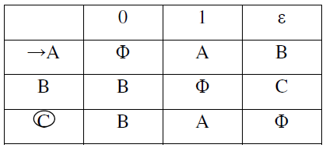 | [6M]
(b) | Construct the Moore machine to determine residue mod 3. | [4M]
(c) | Convert the above Moore machine into Mealy machine. | [4M]

